S3 AWS Creation of Bucket and upload files

**Step 1: Log in to AWS Management Console**

Go to AWS CONSOLE

Click **Sign In** and enter your AWS credentials.

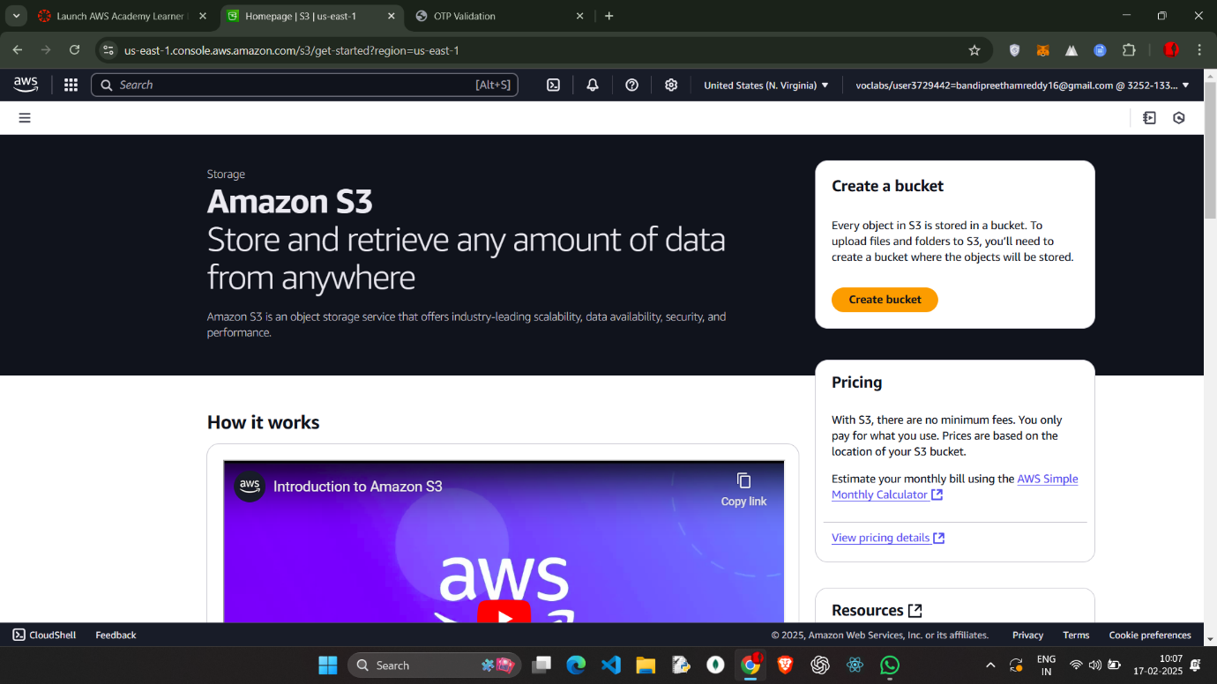

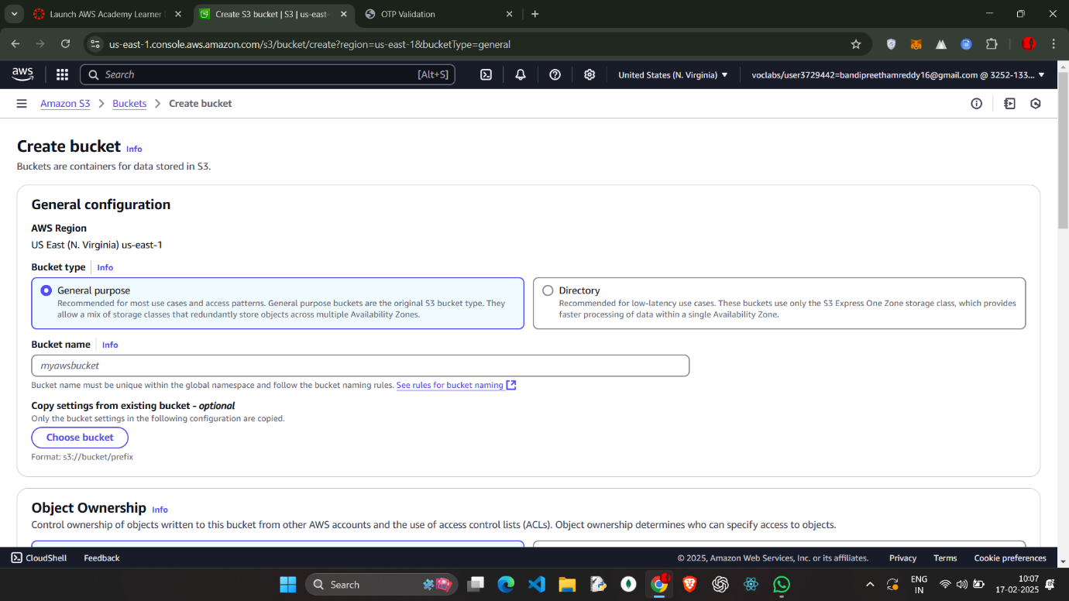

Enter the bucket name bucket name should not have special char and no caps 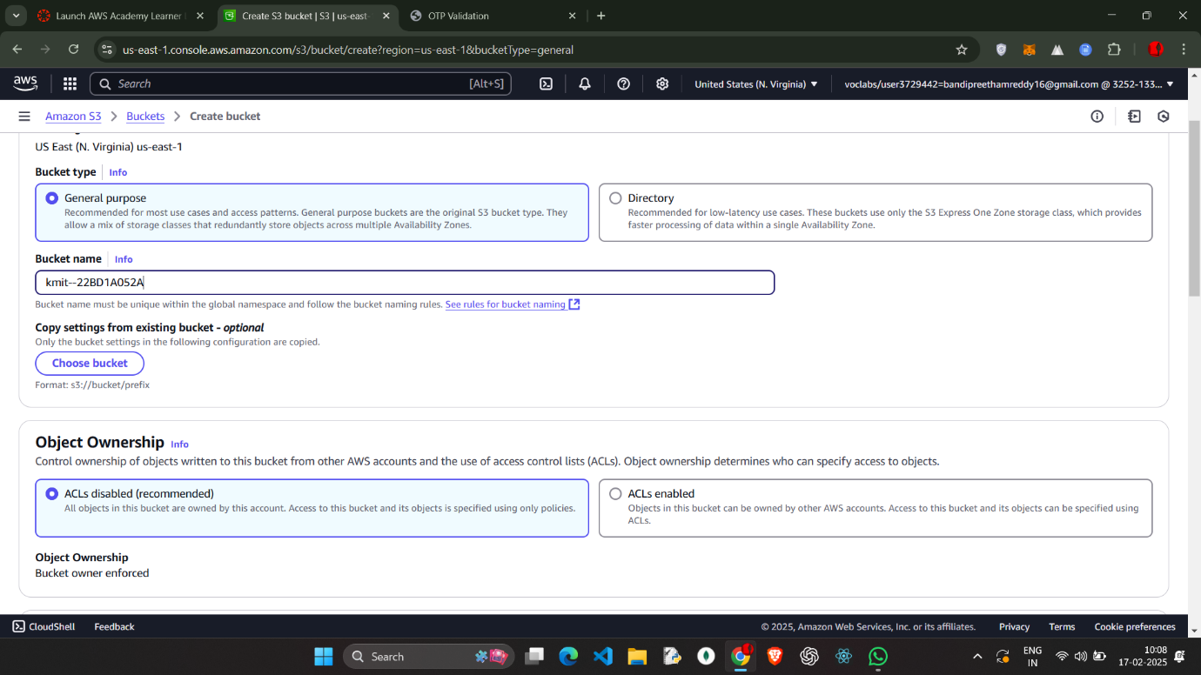

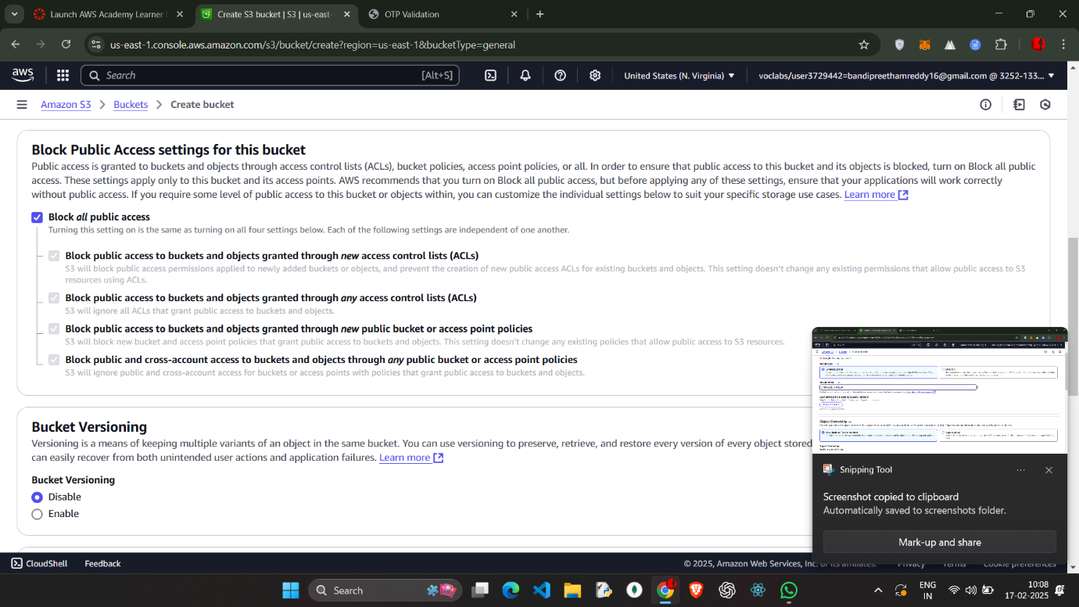cCREte bucket

**Step 2: Upload Files to S3**

1. Open the newly created bucket.
2. Click the **Upload** button.
3. Click **Add files** and select the files to upload.

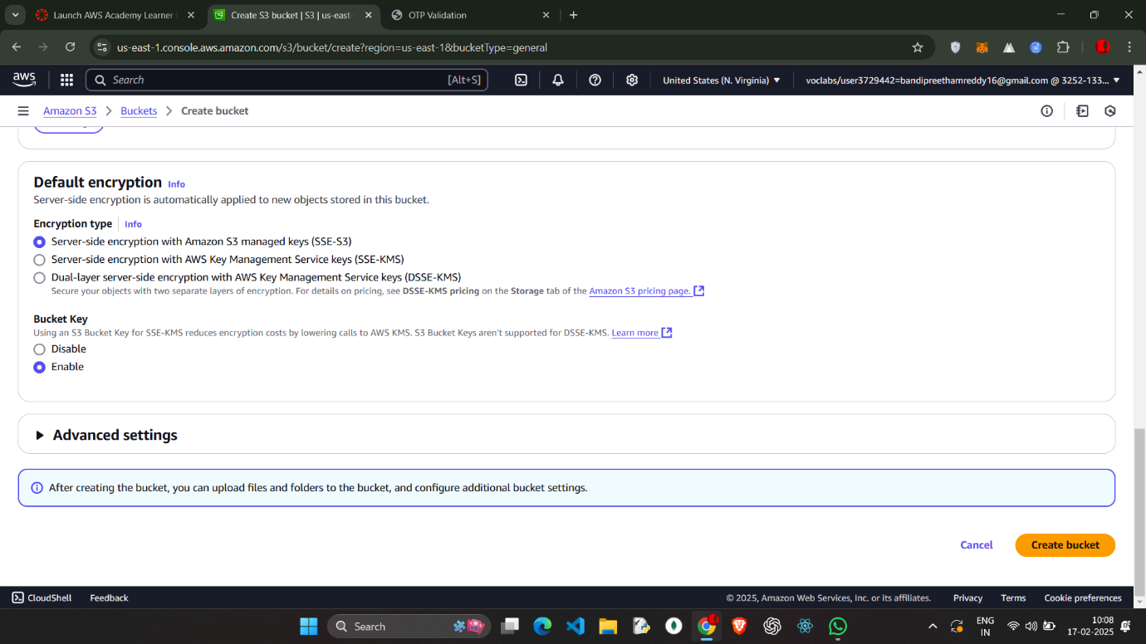

Go to the **Objects** tab in your bucket.

Select the uploaded file.

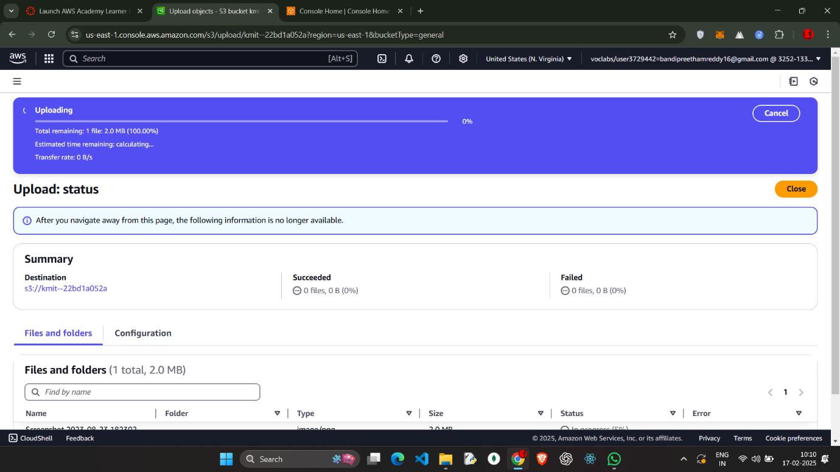the file uploaded success 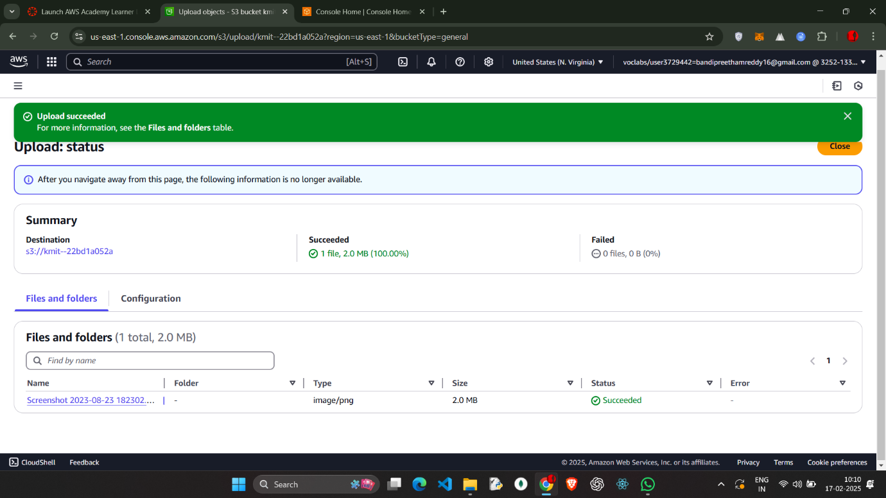 Click **Permissions** → **Edit**.

Under **Public access**, choose **Grant public read access**.

Click **Save changes**.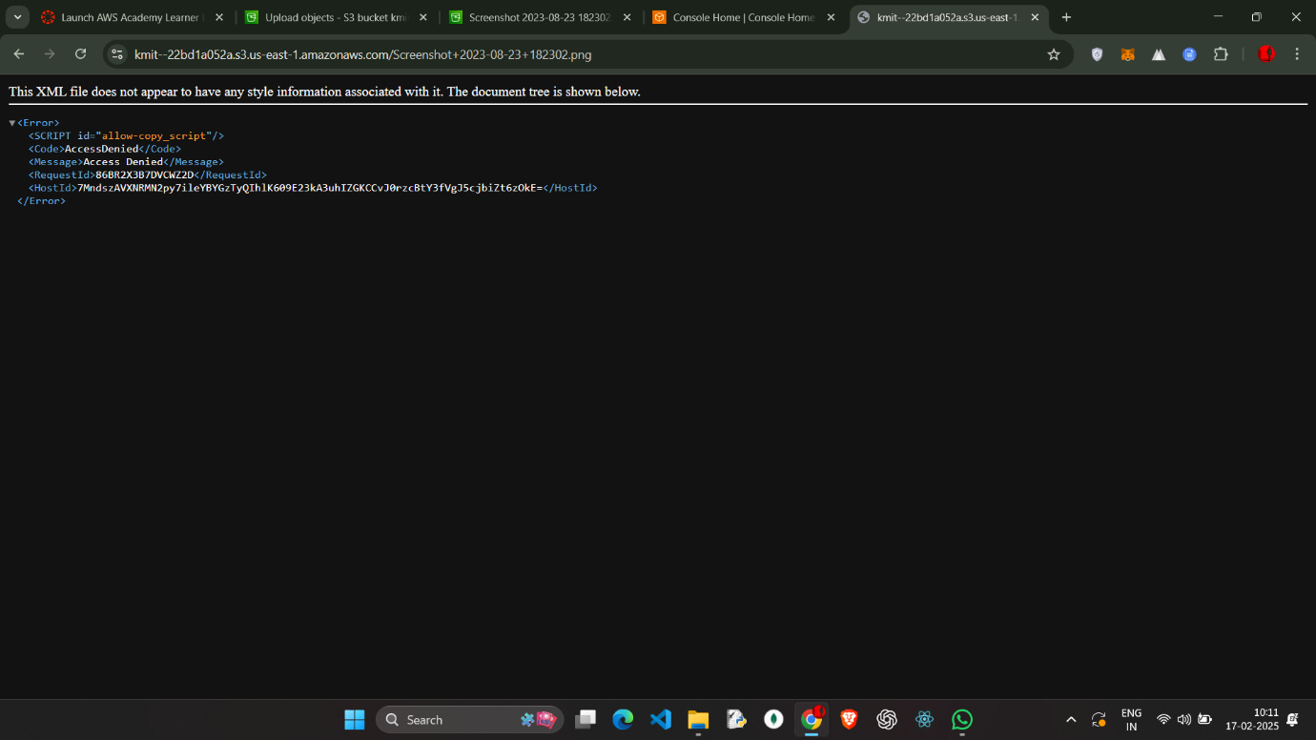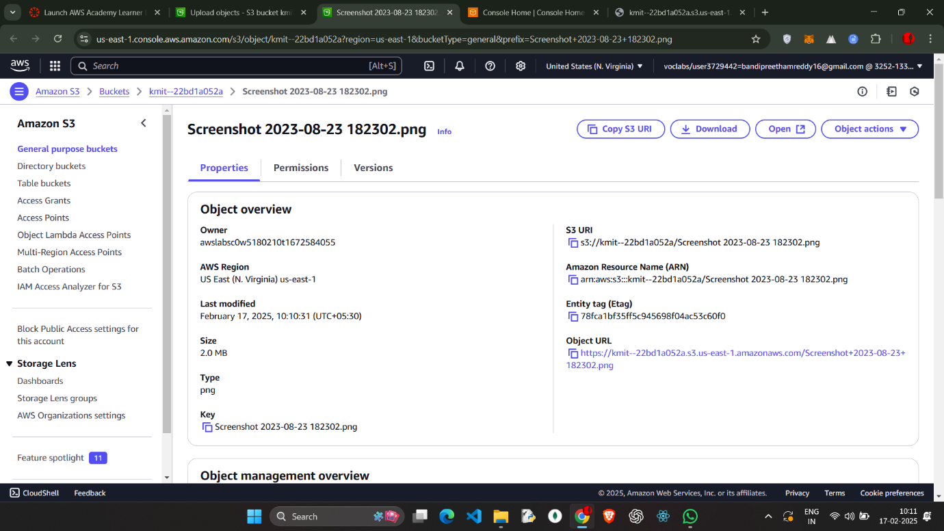

Ssave the changes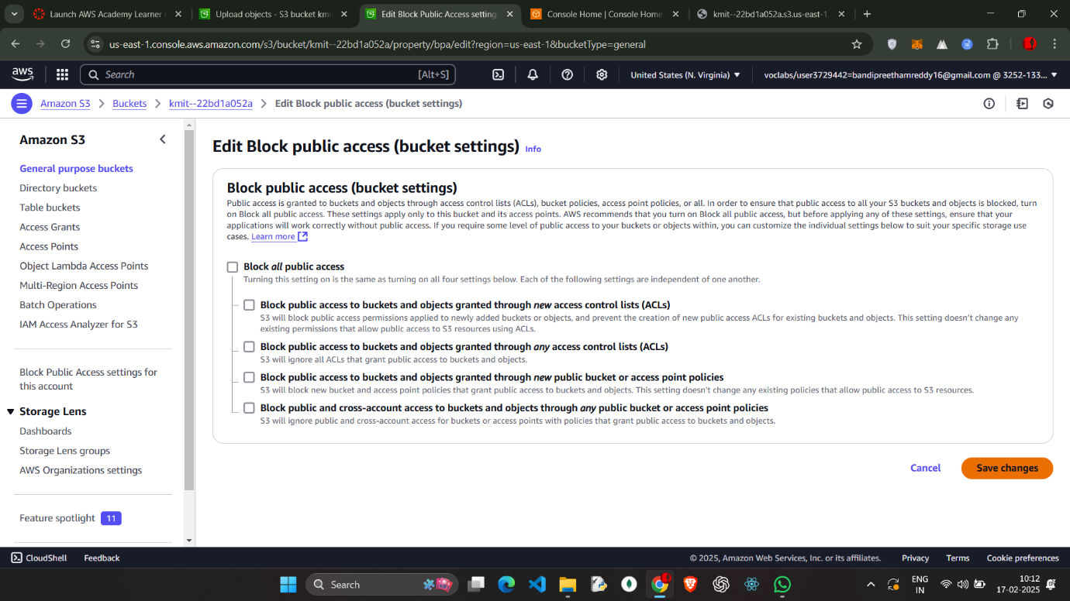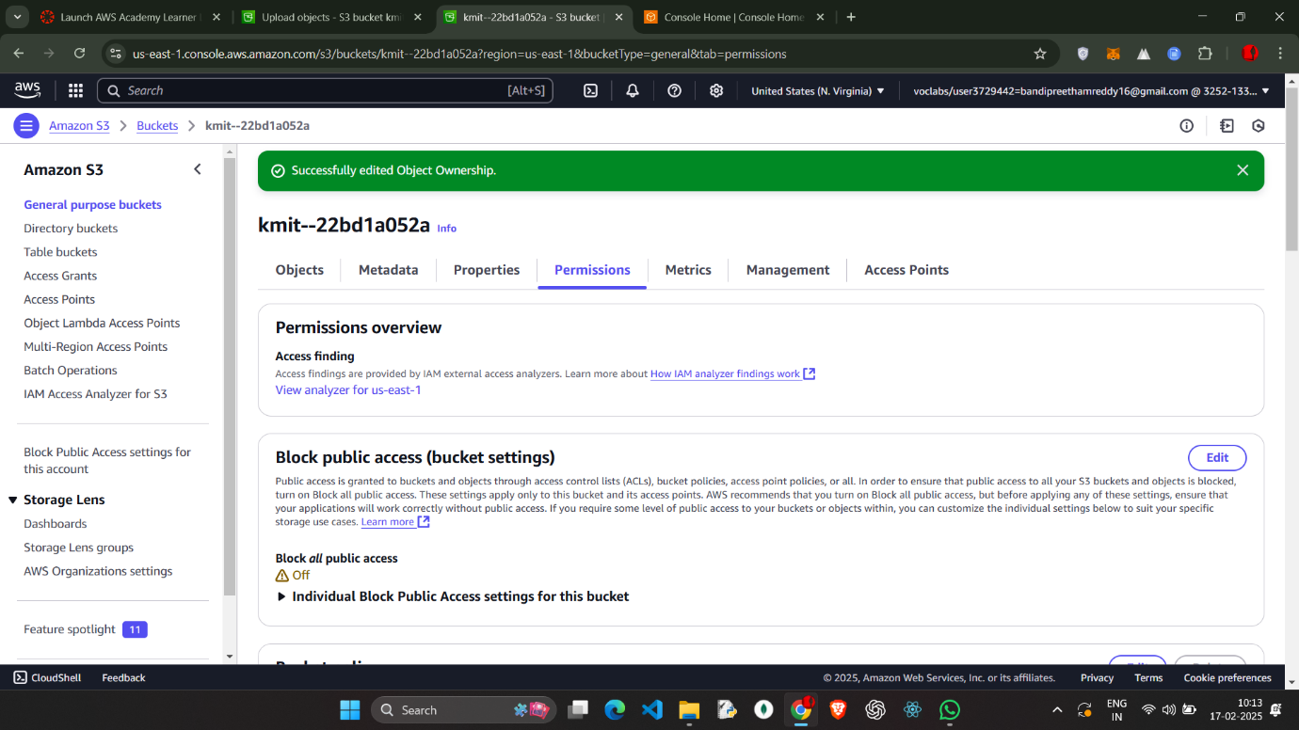

Change the permissions to give me public access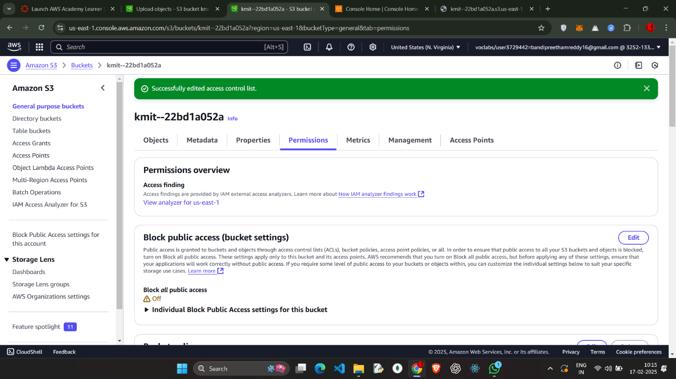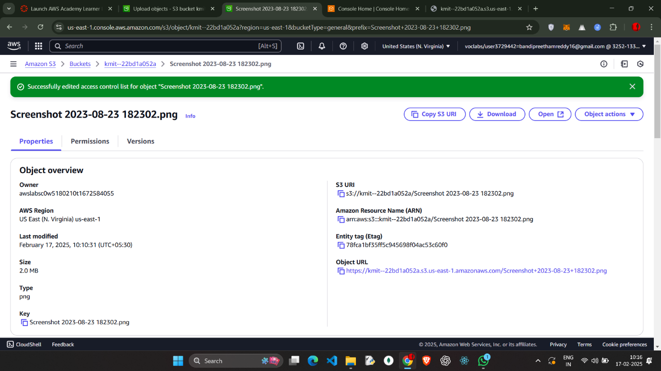

Open the URL to view the image

URL: https://kmit--22bd1a052a.s3.us-east-1.amazonaws.com/Screenshot+2023-08-23+182302.png